SMARTER CALENDAR SYSTEM

System Requirements Specification Document v 1.0

Nilay Das

Table of Contents:

Introduction 3
Scope: 3
Management Summary 3
System Objectives / Overview 3
Figure 1 System Context Diagram 4
Refrences 5
Initial requirement document 5
Common requirements: 5
Error & Exception Handling Requirements 5
Auditing/Logging Requirements 5
Functional Requirement 1 – Create New user 5
Brief Description 5
Interface Details 6
Table of requirement 6
UI Validation 6
Functional Requirement 2 – Login 6
Brief Description 6
Interface Details 6
Table of requirement 7
Functional Requirement 3 – Setting alert 7
Brief Description 7
Interface Details 7
Table of requirement 8
Validation 8
Database Schema: 8
SQL Script for table creation: 9
Test Cases: 9
Unit Test Cases – SCS 9
NFR – Test cases 9
Disclaimer 10
Products to be used: 10
Resource & References: 11

Introduction

Scope:

This document describes the scope of the requirements for the Smarter Calendar System (SCS) for ABC Corp. The document details all the high level requirements with intent to validate ABC’s requirements. This document should be used by the Architect and the developers to design the Solution Architecture for the project.
The web application to be developed is the SCS.

Management Summary

ABC Corp is planning to host a web calendar which can help users to set alert on specific occasions based on calendar events
Important occasions are lost unless we remember like birthdays of near and dear ones. ABC is coming out with an idea to host a website where by a user can login and set an alert for such occasions. This site will remind that user about the upcoming event based on the trigger set by the user while creating it.

System Objectives / Overview

Email

SCS
User

Figure 1 System Context Diagram

The diagram above explains the main conceptual elements in the solution and its
relationships with the architecture. The SCS is the web application. A user can login to the application and can customize his calendar for triggering email for an entered event. The application keep track of the user option, and accordingly triggers an email when the event occurs as per the specifics mentioned by the user and send him an email alert.

SCS | Core application that’s is to be developed for customizing an user calendar, based on user setting it should trigger an email as per the user defined text and sends him the mail when the event happens

Refrences:

Initial requirement document –

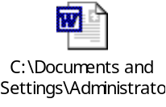

Common requirements:

Error & Exception Handling Requirements
If an error is encountered in sending email notification, it should retry for 3 times and then log it for manual intervention

Auditing/Logging Requirements
Proper logging has to be taken care in the application. Logging has to be segregated viz. info, debug, error & exception

Functional Requirement 1 – Create New user

Brief Description
Create New user screen should allow new user to be created so that the user can use those credentials to login to the application.

Interface Details
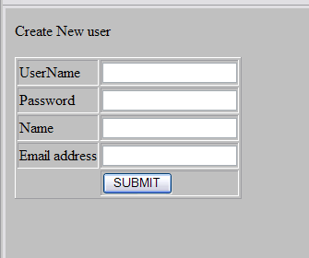.

Table of requirement
UserName | TextBox - username for login to be created
Password | TextBox – Password for login to be created
Name | TextBox – Name of the User who creates it
Email address | TextBox – Email address of the user

UI Validation
Proper Java scrip validation needs to be done for null field

Functional Requirement 2 – Login

Brief Description

The login screen allows an already registered user to log in to the application.

Interface Details
The following schema describes the login interface
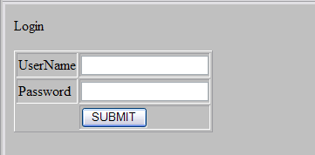

Table of requirement
UserName | TextBox - username for login to be created
Password | TextBox – Password for login to be created
SUBMIT | Button - clicking the submit button will send the username and password for login authentication

Functional Requirement 3 – Setting alert

Brief Description
The setting alert screen will allow the user to set alert on a specific date.

Interface Details
The following schema describes the login interface
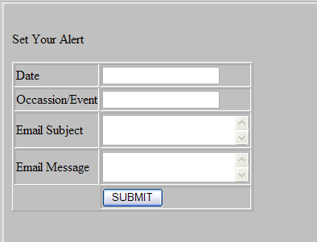

Table of requirement
Date | TextBox - The date for which the alert is set
Occasion/Event | TextBox – Title of the alert
Email Subject | Text Area – the subject line of the alert mail message
Email message | Text Area – the body of the email message to be triggered for the alert
Submit | Button - Submits the entered data

Validation
Proper java script validation to be done for necessary fields

Database Schema:

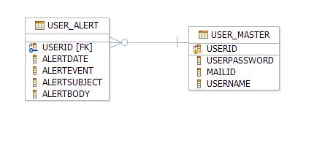

SQL Script for table creation:

This DB scrips were prepared against the derby DB for the above topology.

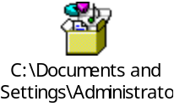

Test Cases:

Unit Test Cases – SCS

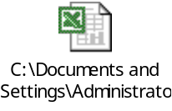

NFR – Test cases

Disclaimer

Most of the DB requirements are captured in the specification. But while developing the solution if the developer has a valid point to add more fields then it can be accommodated after consultation since the DB schema is not freezed as yet.

Products to be used:
Scenario | Product | Description
Developing Use case & UML related activites | IBM Rational Software Modeler, (RSM) | All the UML related specs needs to be developed using Violate only.
Development | Eclipse | The development of Java/J2EE artifacts should be on Eclipseonly
Database | MySql | For all the DB requirements, the team should use MySql only
Team repository | Tortoise | The project team should share there artifacts between them using Tortoise
Deployment – Java/J2EE solutions | JBOSS Application Server | The team should deploy their solutions for testing/production JBoss Application server

